Super-Empowering the Aura

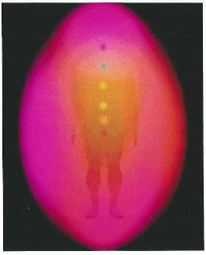
“’Humanity Will Never be Able to Heal Disease and Illness
Until it Learns How to Heal the Aura” Quote from the Rosicrucian Order 1970

Super-Empowering the Aura
For the past 20 years, researcher, Spiritual Elder & Board Certified Hypnotherapist Rod Kelly has been delving into mysteries behind this issue.
His quest for insights on the reasoning behind this bold statement began for Rod after waging a seven year battle with an unstoppable blood clotting issue which precipitated in over 30 hospitalizations; three N.D.E. (near death experiences); and a major stroke that severely impacted his left side.
Searching for answers, Rod’s surgeon and primary care physicians sent him to Harvard’s Medical Center to be seen by the head of the neurology in hopes of discovering a solution for his blood clotting issues.
When even they couldn’t come up with answers Rod moved back to Canada and took up residence on a Native Reservation where he became a student of a prominent Cree Elder, who taught him how to connect to his own Spirit.
Through this connection Rod learned that Spirit is the source of our instincts; insights & intuitions.
Instinctively Rod learned and began practicing a technique that was later discovered to hold the secret to intensifying and healing the Aura.
In a chance meeting at a Women’s Health Expo, Rod connected with a woman that owned an aura photography system. Arrangements were made and along with a small group of friends, they participated in an experiment to verify the effects on his technique on the aura.
Before and after demonstrating the technique, it was discovered that the technique had far exceeded their expectations.
The equipment that was used was a Kirlian Photography system that was originally developed by Nicola Tessla in the late 1890’s.
Not only was the camera system able to scientifically validate the aura’s healing completely, but it also validated a huge impact on the entire Chakra system.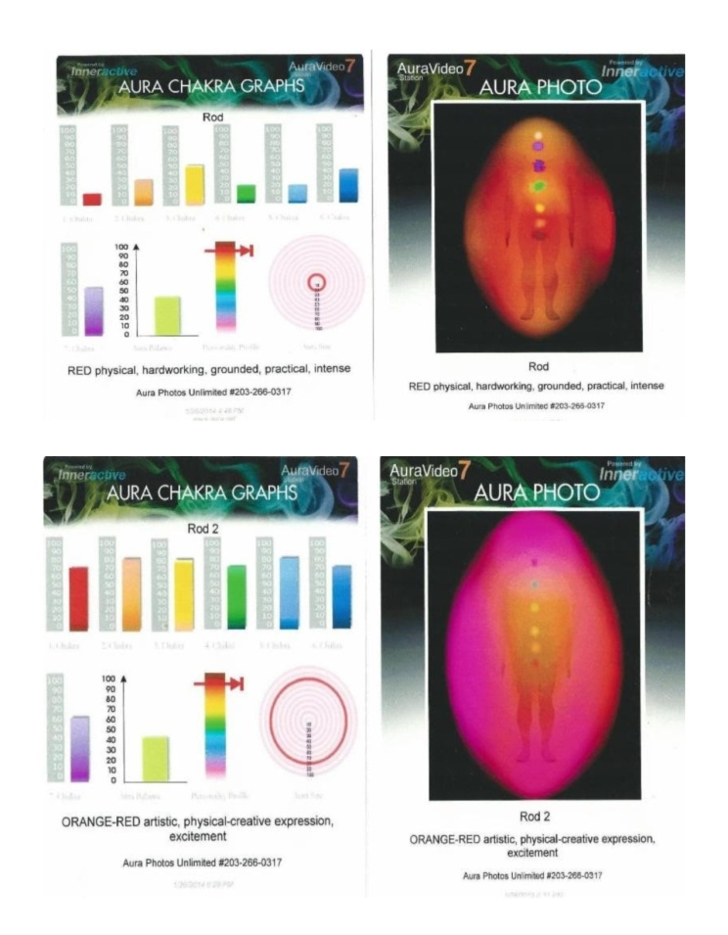

BEFORE IMAGES
The various colored columns represent the Chakras and their various levels of openness. The lime green column represents the normal desired level for each of the Chakras. The target represents the size of the aura.

AFTER IMAGES
Note the uniformity and intensity of the Aura. When comparing the Chakra columns there is no doubt of the tremendous impact on the levels of openness on the entire system. Next is the expanse of the aura, itself. It went from under a foot to just over five feet.
The most amazing aspect of this is that the technique only took a daily 5 minute exercise to achieve
This posed many questions.
- What is the Aura?
- What is its purpose?
- What is it comprised of?
- How does it impact the Chakras?
- What is the cause of the depletion of its energy?
- How can it be re-energized?
- How would healing the aura have any impact on the body’s health at all?
These are only a few of the questions that came up. As answers surfaced, the intensity of new questions rose exponentially.
The new questions required different perspectives. They required a rudimentary level of viewing. It demanded that I begin looking at the absolute base line. What is the energetic composition of disease and illness?
What role does the Aura play in this energetic perspective? How does it work? Why does it work?
The answers to these questions relied on laws in Physics & Universal Laws. This is where Science & Spirituality provide a solid foundation for healing.
ANSWERS

First of all, the aura is an energetic field of white light that surrounds the body. Most people are capable of seeing it over a person’s head. It’s most visible when the person they are seeing is standing in front of a white wall. Most often we ignore it because it is so commonplace. To see it, you have to look for it.
It derives its colors through its connection with the body’s major energy centers,(the Chakra System). There are seven Chakras in the body and each Chakra has its designated colors, following the colors of the rainbow. Whichever Chakra is dominant its respective color will dominate the Aura.
The Aura is also the reservoir of energy that supplies all of the energy for the entire body. When the Aura is in a weakened state, there is a shortage of usable energy that radiates throughout the body. It’s as if there was a drought and the Chakras had to compete for their supply of energy. Without an adequate supply of energy, the body’s defense systems diminishe, and the doors for disease and illness fly wide open.
For literally thousands of years, advanced civilizations have devised a plethora of techniques, such as acupuncture, reiki and a number of other techniques to address the energy shortage of individual Chakras.
However, there is a law in physics that states, “For every action there is an equal but opposite reaction.” When additional energy is drawn into the specific Chakra, it has to draw that energy from someplace and subsequently it draws it from one or more of the other Chakras.
The problem isn’t isolated to any specific Chakra. It’s actually an issue that involves the entirety of the Chakra system. It simply doesn’t have the supply of energy that would be required to function at is full potential.
However when the Aura is intensified the reservoir of usable energy is dramatically increased. When the reservoir is full, literally all of the Chakras gorge themselves and the entire energy systems flow unobstructed, as the above diagram validates.
A description of the technique for super empowering the aura will be discussed later in this paper.
(See diagrams above)
But the roll of the aura doesn’t stop there. Not by a long shot!
Our minds act as a relay station that transmits information to our aura.
A recent discovery through Quantum Physics established a new understanding about memories that outdates previous understandings.
It had long been believed that our memories were stored in the area of the brain that is often referred to as the subconscious mind.
Quantum Physics has scientifically proven that our memories are actually stored in the energy field that is just outside of the body. That energy field is the aura.
To give you a better idea of the importance of this, just take another look at the after diagram of the aura. Imagine the size of the human brain. Then compare it to the size of the aura.
Science has proven that our mind is incapable of forgetting anything. All of our thoughts get stored in a single cell. How many thought cells could the mind house? The mind still is the relay station, but the actual information is perpetually stored in our aura.
Now the big guns! The aura is our Spirit. When the aura becomes super empowered, what kind of an impact do you think it would have on your own Spirit? (Kirlian Photography has validated the understanding that the Spirit is in fact the Aura)
To understand how the aura/ Spirit influences the body’s state of health, you need to understand more about the role the Spirit /aura play in your lives.
Your Spirit is the source of our:
- Instincts
- Intuitions
- Insights
- & Your Dreams.
As the aura/spirit reaches their increased energy levels, the strength of all three of them raise proportionately. However, one must be receptive of these messages. How often do we normally ignore them?
Because of the increased intensity, it becomes easier to be more aware of their messages.
This is a key element in the healing processes. Your instincts; intuition & dreams often provide the segue to healing. Listen and accept their wisdom!
Your Spirit is the essence of Unconditional Love. Its purpose for existence is to protect and guide you on your journey through life. It has no concept of time, so it can easily see in both the past and the future with clarity. So its guidance is impeccable.
Unconditional Love in itself is a major healing element because it is pure essence of positive energy.
On an energetic level, disease and illness have high levels of negative energy.
There is a low in physics that states, “Positive energy consumes negative energy”
Positive energy is light, and light is information. To be enlightened is to learn.
In the 1623 Galileo made a public proclamation that stated, “Everything that ever was, is or will be had to have a purpose for existing, because without purpose, nothing can exist”. For over 400 years, this has passed the scrutiny of science, and has been accepted.
With this being stated, doesn’t it make sense that there would be a reason for your medical condition to exist? What is its purpose, and how is it best served? When the purpose is understood and internalized, the resistance to healing diminishes…
Begin by re-discovering the beauty in your world and then embrace it.

For additional information contact Rod Kelly
HealtheMindBody.com
Info@HealTheMindBody.com
860-216-8671

